Aim: To obtain the best-fit line over single-feature scattered data points using Linear Regression
IDE: Google Colab

Theory:

Linear regression is a method for determining the best linear relationship between two variables, X and Y. If variables X and Y are uncorrelated, it is pointless to embark upon linear regression. However, if a reasonable degree of correlation exists between X and Y, then linear regression may be a useful means to describe the relationship between the two variables. The usual approach is to use the least-squares method, which minimizes the squared difference between the actual data points and a straight line. Let [x_{i}, y_{i}], i = 1,2, 3, …, N, be the N pairs of data values of the variables X and Y. The straight-line relating X and Y is y = mx + c, where m and c are the gradient and constant values (to be determined) defining the straight line. Thus, y(x_{i}) - y_{i} is the difference between the line and data point i (see Fig. 1). Taking all the data points, we seek values of m and c that minimize the squared difference SD.
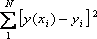

This is achieved by calculating the partial derivatives of SD with respect to m and c and finding the pair [m, c] such that SD is at a minimum.
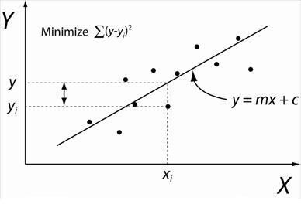

Figure 1: Illustration of Linear Regression. Linear least squares regression, the idea is to find the line y = mx + c that minimizes the mean squared difference between the line and the data points

Batch Gradient Descent:
Gradient Descent is an optimization algorithm used to minimize a cost function in various machine learning algorithms. It is basically used for updating the parameters of the learning model. Batch gradient descent, which processes all the training examples for each iteration of gradient descent. But if the number of training examples is large, then batch gradient descent is computationally very expensive.
Let m be the number of training examples. Let n be the number of features.

Algorithm for batch gradient descent:
Let h_{θ}(x) be the hypothesis for linear regression. Then, the cost function is given by:
Let Σ represent the sum of all training examples from i=1 to m.
J_{train}(θ) = (1/2m) Σ( h_{θ}(x^{(i)}) - y^{(i)})²
Repeat {
θj = θj – (learning rate/m) * Σ( h_{θ}(x^{(i)}) - y^{(i)})x_{j}^{(i)}
For every j =0 …n
}
Where x_{j}^{(i)} represents the j^{th} feature of the i^{th} training example, so if m is very large (e.g., 5 million training samples), then it takes hours or even days to converge to the global minimum. That’s why, for large datasets, it is not recommended to use batch gradient descent as it slows down the learning.

Pre-Lab Exercise:
- Explain the meaning of linear regression
Linear regression means estimating the relationship between a scalar response, that is, the dependent variable, and one or more explanatory variables (regressor or independent variable).
Linear regression is a method for determining the best linear relationship between two variables, X and Y.
- Write three applications of linear regression
The applications of linear regression are:
- Market analysis by using some marketing strategies and maximizing sales;
- Predicts the impact of water and air pollution on the environment;
- Recognizes high-risk patients and improves healthy lifestyles.

- Write three advantages of linear regression
The advantages of linear regression are:
- Linear regression is a relatively simple algorithm, making it easy to understand and implement. The coefficients of the linear regression model can be interpreted as the change in the dependent variable for a one-unit change in the independent variable, providing insights into the relationships between variables.
- Linear regression is relatively robust to outliers compared to other machine learning algorithms. Outliers may have a smaller impact on the overall model performance.
- Linear regression is computationally efficient and can handle large datasets effectively. It can be trained quickly on large datasets, making it suitable for real-time applications.
- Write three limitations of linear regression
- Linear regression assumes a linear relationship between the dependent and independent variables. If the relationship is not linear, the model may not perform well.
- Linear regression is sensitive to multicollinearity, which occurs when there is a high correlation between independent variables. Multicollinearity can inflate the variance of the coefficients and lead to unstable model predictions.
- Linear regression assumes that the features are already in a suitable form for the model. Feature engineering may be required to transform features into a format that can be effectively used by the model.

Methodology:
- Load the basic libraries and packages
- Load the dataset
- Analyze the dataset
- Pre-process the data
- Visualize the Data
- Separate the feature and prediction value columns
- Write the Hypothesis Function
- Write the Cost Function
- Write the Gradient Descent optimization algorithm
- Apply the training to the dataset to minimize the loss
- Find the best-fit line to the given dataset
- Observe the cost function vs iterations learning curve

Program (Code):
Simple Linear Regression
import numpy as np
import matplotlib.pyplot as plt
def estimate_coef(x, y):
n = np.size(x)
m_x = np.mean(x)
m_y = np.mean(y)

SS_xy = np.sum(x * y) - n * m_x * m_y
SS_xx = np.sum(x * x) - n * m_x * m_x

b_1 = SS_xy / SS_xx
b_0 = m_y - b_1 * m_x

return b_0, b_1
def plot_regression_line(x, y, b):
plt.figure(figsize=(6,4))
plt.scatter(x, y, color="red", label="Data points")
y_pred = b[0] + b[1] * x
plt.plot(x, y_pred, color="blue", label="Regression line")
plt.xlabel("X")
plt.ylabel("Y")
plt.legend()
plt.show()

x = np.array([0,1,2,3,4,5,6,7,8,9])
y = np.array([1,3,2,5,7,8,8,9,10,12])

b = estimate_coef(x, y)
print("b0 =", b[0])
print("b1 =", b[1])

plot_regression_line(x, y, b)

Multiple Linear Regression
from sklearn.model_selection import train_test_split
import matplotlib.pyplot as plt
import numpy as np
from sklearn import datasets, linear_model, metrics
import pandas as pd

data_url = "https://lib.stat.cmu.edu/datasets/boston"
raw_df = pd.read_csv(data_url, sep="\s+",skiprows=22, header=None)
X = np.hstack([raw_df.values[::2, :],raw_df.values[1::2, :2]])
y = raw_df.values[1::2, 2]
X_train, X_test,\
y_train, y_test = train_test_split(X, y,test_size=0.4,random_state=1)
reg = linear_model.LinearRegression()
reg.fit(X_train, y_train)
# regression coefficients
print('Coefficients: ', reg.coef_)

# variance score: 1 means perfect prediction
print('Variance score: {}'.format(reg.score(X_test, y_test)))

# plot for residual error

# setting plot style
plt.style.use('fivethirtyeight')

# plotting residual errors in training data
plt.scatter(reg.predict(X_train),
reg.predict(X_train) - y_train,
color="green", s=10,
label='Train data')

# plotting residual errors in test data
plt.scatter(reg.predict(X_test),
reg.predict(X_test) - y_test,
color="blue", s=10,
label='Test data')

# plotting line for zero residual error
plt.hlines(y=0, xmin=0, xmax=50, linewidth=2)

# plotting legend
plt.legend(loc='upper right')

# plot title
plt.title("Residual errors")

# method call for showing the plot
plt.show()

Polynomial Linear Regression
import pandas as pd
import matplotlib.pyplot as plt
import seaborn as sns
import sklearn
import warnings

from sklearn.preprocessing import LabelEncoder
from sklearn.impute import KNNImputer
from sklearn.model_selection import train_test_split
from sklearn.preprocessing import StandardScaler
from sklearn.metrics import f1_score
from sklearn.ensemble import RandomForestRegressor
from sklearn.ensemble import RandomForestRegressor
from sklearn.model_selection import cross_val_score

warnings.filterwarnings('ignore')

df = pd.read_csv('/content/Position_Salaries.csv')

X = df.iloc[:,1:2].values
y = df.iloc[:,2].values
[x,y]
from sklearn.linear_model import LinearRegression
lin_reg=LinearRegression()
lin_reg.fit(X,y)
from sklearn.preprocessing import PolynomialFeatures
poly_reg2=PolynomialFeatures(degree=2)
X_poly=poly_reg2.fit_transform(X)
lin_reg_2=LinearRegression()
lin_reg_2.fit(X_poly,y)

poly_reg3=PolynomialFeatures(degree=3)
X_poly3=poly_reg3.fit_transform(X)
lin_reg_3=LinearRegression()
lin_reg_3.fit(X_poly3,y)
plt.scatter(X,y,color='red')
plt.plot(X,lin_reg.predict(X),color='green')
plt.title('Simple Linear Regression')
plt.xlabel('Position Level')
plt.ylabel('Salary')
plt.show()
plt.style.use('fivethirtyeight')
plt.scatter(X,y,color='red')
plt.plot(X,lin_reg_2.predict(poly_reg2.fit_transform(X)),color='green')
plt.plot(X,lin_reg_3.predict(poly_reg3.fit_transform(X)),color='yellow')
plt.title('Polynomial Linear Regression Degree 2')
plt.xlabel('Position Level')
plt.ylabel('Salary')
plt.show()
plt.style.use('fivethirtyeight')
X_grid=np.arange(min(X),max(X),0.1) # This will give us a vector.We will have to convert this into a matrix
X_grid=X_grid.reshape((len(X_grid),1))
plt.scatter(X,y,color='red')
plt.plot(X_grid,lin_reg_3.predict(poly_reg3.fit_transform(X_grid)),color='lightgreen')

#plt.plot(X,lin_reg_3.predict(poly_reg3.fit_transform(X)),color='green')
plt.title('Polynomial Linear Regression Degree 3')
plt.xlabel('Position Level')
plt.ylabel('Salary')
plt.show()

Results:
To be attached with
- Datapoints scattering (without best-fit line)

- Scatter plot showing the best-fit line in the last iteration of training
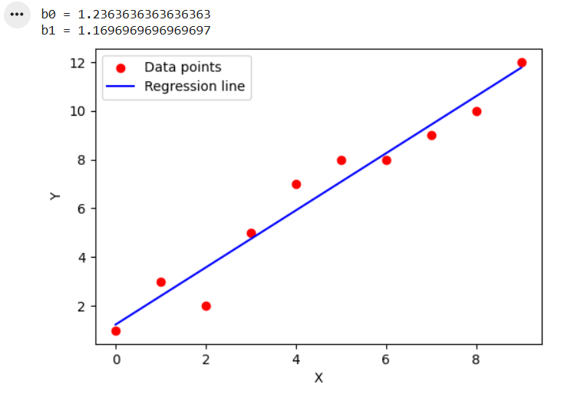
Multiple Linear Regression
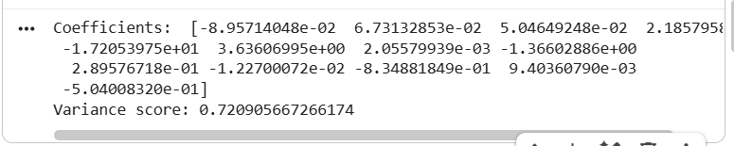

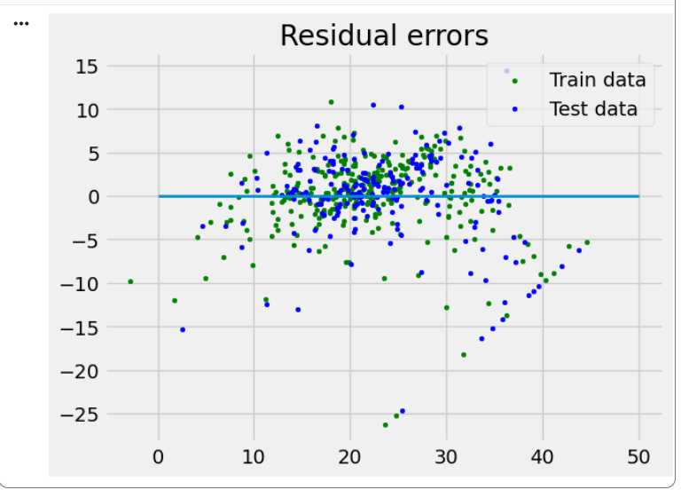

Polynomial Linear Regression
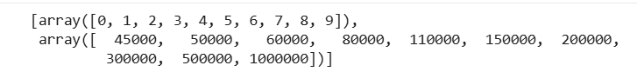

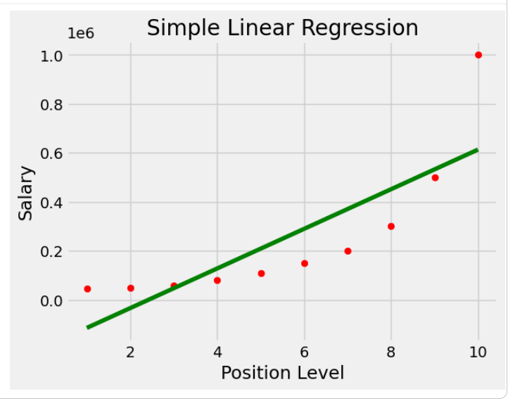

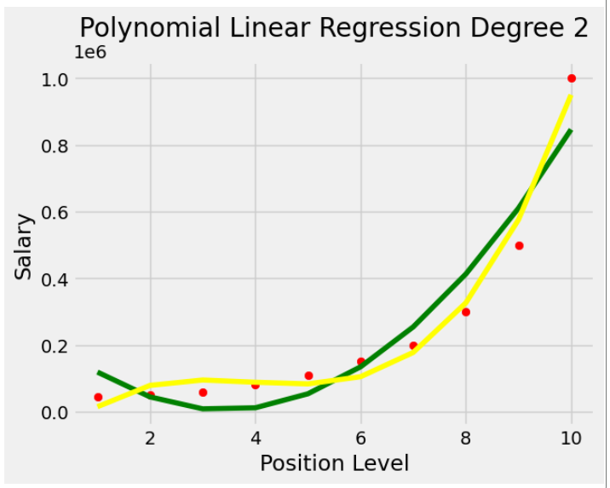

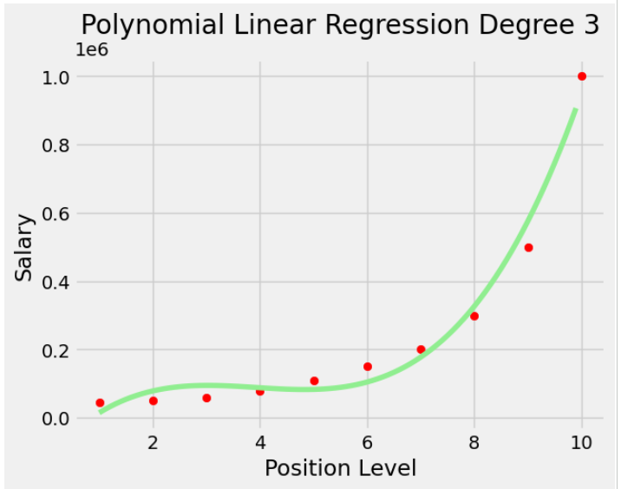

Observation and Result Analysis:
- Nature of the dataset

- During Training Process

- After the training Process

Post Lab Exercise:
- What are the major assumptions considered in linear regression
The major assumptions considered in linear regression are:
- Linearity: the relationship between the dependent and independent variables is linear;
- Independence: the observations are independent of each other;
- Homoscedasticity: the variance of errors is constant across all levels of the independent variables;
- Normality: the errors follow a normal distribution;
- No multicollinearity: the independent variables are not highly correlated with each other;
- No endogeneity: there is no relationship between the errors and the independent variables.
- Why MSE is used instead of MAE for calculating the loss function
Mean Squared Error (MSE) is used instead of Mean Absolute Error (MAE) because:
- Differentiability: MSE is differentiable everywhere, while MAE is not differentiable at zero, making optimization harder.
- Penalizes large errors more: Squaring errors gives more weight to large errors, helping models reduce big mistakes more aggressively.
- Mathematical convenience: leads to a closed-form solution (Normal Equation), works well with gradient descent.
- MSE corresponds to maximum likelihood estimation under Gaussian noise.
MSE provides smoother optimization and stronger penalization of large errors, making it suitable for linear regression.
- How can the behavior of outliers be understood while dealing with the unseen dataset?
Outliers in unseen data can significantly affect the model's performance. Their behavior can be understood using the approaches:
- Residual analysis: large residuals indicate possible outliers; plot residuals vs predictions to detect unusual patterns.
- Leverage and influence measures: high-leverage points have extreme feature values. Cook’s distance helps measure the influence of data points.
- Robust evaluation metrics: compare MSE vs MAE (MAE is less sensitive to outliers); a large difference indicates outlier impact.
- Distribution comparison: compare training and test feature distributions; sudden shifts suggest unseen outlier patterns.
- Model performance drop: significant error increase on test data indicates outlier sensitivity.

- Derive the Normal Equation for the Linear Regression.
